Analysis of Lead Content in Flint Tap Water Before and After Flushing

1. Abstract
This report details the analysis of lead concentrations in tap water samples from Flint, Michigan, comparing levels measured before flushing ('first draw') and after flushing the tap for a period. Using the provided flint.csv dataset and Python libraries (pandas, matplotlib, seaborn, scipy, statsmodels), the analysis aimed to determine the effectiveness of flushing and understand the relationship between pre- and post-flush lead levels. Exploratory data analysis revealed highly variable and skewed lead concentrations with significant outliers. A paired t-test confirmed a statistically significant decrease in mean lead levels after flushing (approx. 7 ppb reduction, p < 0.001). While a moderate positive correlation (r ≈ 0.55) and a significant linear regression model were found, the lead level before flushing explained only about 30% (R² ≈ 0.30) of the variance in post-flush levels. Recommendations include continuing flushing as a general mitigation practice, investigating high-outlier locations, and acknowledging the limitations of using pre-flush data alone to predict post-flush outcomes.

2. Introduction

2.1. Problem Statement
Lead contamination in drinking water poses significant public health risks. This analysis focuses on tap water samples from Flint, examining the lead content measured in the initial water drawn after stagnation ("before flushing") compared to water drawn after the tap has been run ("after flushing").

2.2. Background
Water sitting stagnant in plumbing, especially older systems with lead pipes or solder, can leach lead. The "first draw" sample (represented by pb_1 in the data) typically represents the highest concentration from water sitting in immediate pipework. Flushing (running the tap for a period) clears this stagnant water, drawing water from the main supply. The "after flushing" sample (pb_3 in the data) aims to measure lead levels after this initial purge.

2.3. Objectives
The primary objectives of this analysis were:
- To compare lead concentrations before and after flushing to understand the impact of flushing on lead levels.
- To investigate the relationship between pre-flush and post-flush lead concentrations.
- To identify data characteristics like distribution shape and outliers.
- To provide interpretations of the findings and potential recommendations based on the analysis.

2.4. Data Source
The analysis utilized the flint.csv dataset, containing sample IDs, location information (zip, ward), and lead measurements (pb_1, pb_2, pb_3). For this analysis, pb_1 was interpreted as 'Lead_Before_Flushing' and pb_3 as 'Lead_After_Flushing'.

3. Methodology
The analysis was conducted using Python with the following libraries: pandas for data manipulation, matplotlib and seaborn for visualization, scipy.stats for statistical tests, and statsmodels for regression analysis.
Key steps included:
- Data Loading and Preparation: Loading the flint.csv dataset, inspecting its structure, checking for duplicates and null values, and renaming relevant columns (pb_1, pb_3). Rows with missing values in the lead columns were excluded from comparative analysis.
- Exploratory Data Analysis (EDA): Calculating descriptive statistics. Visualizing data distributions using histograms and assessing normality with QQ-plots. Calculating and visualizing the Pearson correlation coefficient.
- Statistical Testing: Performing a paired t-test to determine if the mean difference between pre- and post-flush lead levels is statistically significant.
- Data Visualization: Creating box plots and scatter plots to compare distributions and visualize relationships.
- Advanced Analysis: Identifying potential outliers using the Interquartile Range (IQR) method and discussing their potential impact. Performing Ordinary Least Squares (OLS) linear regression.

4. Results and Discussion

4.1. Data Quality
The dataset contained 271 samples. Initial checks found no duplicate rows and no missing values in the pb_1 or pb_3 columns used for the primary analysis. Therefore, all 271 samples were included.

4.2. Exploratory Data Analysis
- Summary Statistics: The mean lead concentration before flushing was 10.65 ppb, significantly higher than the median of 3.52 ppb. After flushing, the mean dropped to 3.66 ppb, still higher than the median of 0.83 ppb. The large difference between mean and median, along with high standard deviations (21.56 ppb before, 10.54 ppb after) and high maximum values (158 ppb before, 94.52 ppb after), strongly suggest right-skewed distributions and the presence of high outliers.
- Distributions: Histograms confirmed that both pre- and post-flush lead levels are heavily right-skewed, with most values concentrated at the lower end but a long tail of higher values.

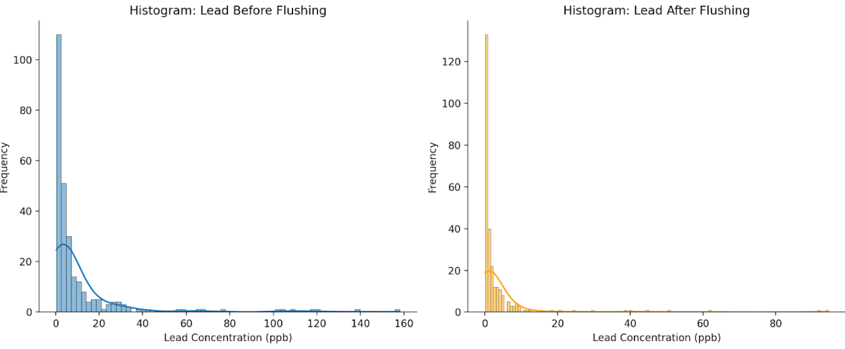

QQ-plots showed significant deviation from the diagonal line, further indicating the data is not normally distributed.

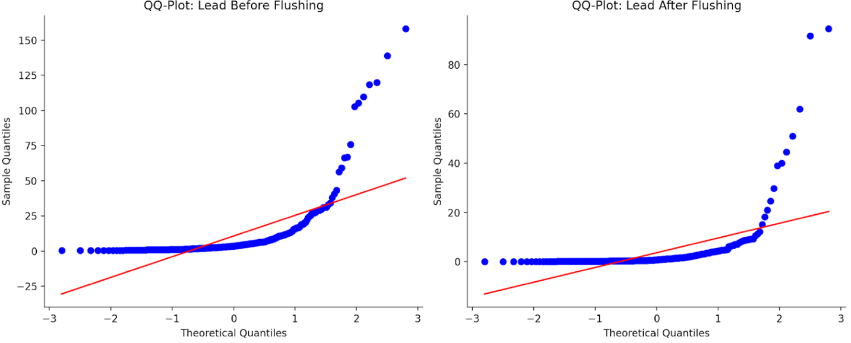

- Correlation: The Pearson correlation coefficient between 'Lead_Before_Flushing' and 'Lead_After_Flushing' was calculated as 0.55. This indicates a moderate positive linear relationship: higher pre-flush levels tend to be associated with higher post-flush levels, but the association is not perfect. The correlation matrix heatmap visually confirmed this moderate positive relationship.

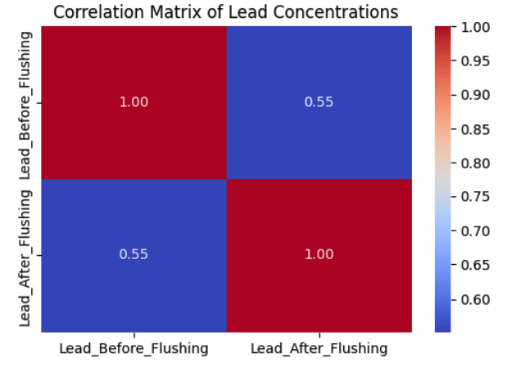

- Outliers: Using the 1.5*IQR method, 33 potential outliers were identified in the 'Lead_Before_Flushing' data (values > 20.26 ppb) and 30 potential outliers in the 'Lead_After_Flushing' data (values > 6.39 ppb). These high values likely inflate the mean values and standard deviations and could disproportionately influence correlation and regression analyses.

4.3. Paired T-Test
A paired t-test was conducted to compare the means of the paired lead measurements (before vs. after) for each sample location.
- Result: The test yielded a t-statistic of 6.37 and a p-value extremely close to zero (7.89e-10).
- Interpretation: Since the p-value is far below the conventional significance level of 0.05, we reject the null hypothesis. There is a statistically significant difference between mean lead concentrations before and after flushing. The mean difference was calculated as 6.99 ppb (10.65 ppb - 3.66 ppb), indicating that, on average, flushing significantly decreases lead levels.

4.4. Data Visualization Insights
- Box Plots: The side-by-side box plots visually supported the t-test results [Image 4]. The median (center line of the box) for 'After Flushing' was substantially lower than for 'Before Flushing' [Image 4]. The interquartile range (length of the box) was also smaller after flushing [Image 4]. Both plots clearly displayed numerous data points beyond the whiskers, corresponding to the outliers identified earlier.

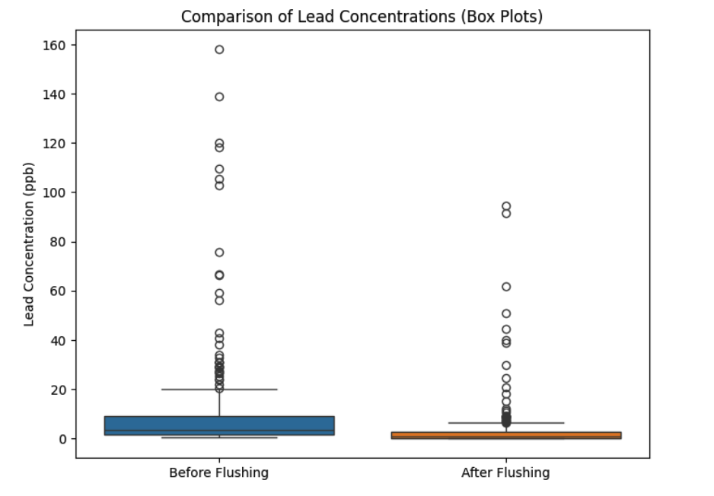

- Scatter Plot: The scatter plot of 'After Flushing' vs. 'Before Flushing' showed a general positive trend, consistent with the correlation coefficient. Most points fell below the 'Before = After' reference line, visually demonstrating that flushing typically resulted in lower lead levels. However, considerable scatter around any potential trend line indicated that the relationship is not tightly linear and other factors influence the post-flush level. Several points with high pre-flush levels still showed relatively high post-flush levels.

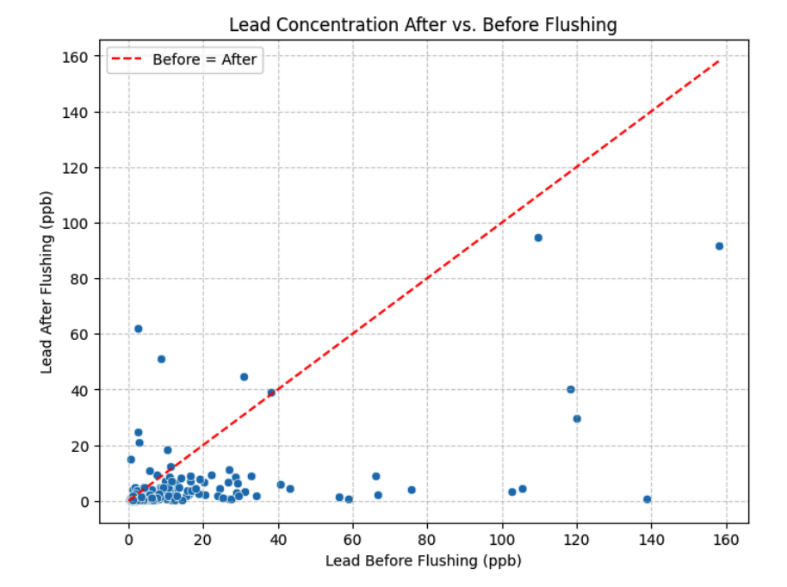

4.5. Linear Regression Analysis
An OLS linear regression was performed to model 'Lead_After_Flushing' as a function of 'Lead_Before_Flushing'.
- Model Fit: The overall model was statistically significant (Prob(F-statistic) = 5.98e-23, far less than 0.05).
- Coefficients: The fitted model equation was approximately: $Lead\_After\_Flushing = 0.7919 + 0.2695 \times Lead\_Before\_Flushing$ The intercept (0.7919) was not statistically significant (P>|t| = 0.186). The slope (0.2695) was highly significant (P>|t| = 0.000), indicating that for each 1 ppb increase in lead before flushing, the lead level after flushing increases by about 0.27 ppb, on average.
- Evaluation: The R-squared value was 0.304. This means that only about 30.4% of the variability in post-flush lead concentrations can be explained by the pre-flush concentrations in this linear model. While statistically significant, this low R-squared confirms that the pre-flush level is only a moderate predictor of the post-flush level. The scatter plot with the regression line visually confirmed this – the line captures a general trend, but many points lie far from it. Tests within the OLS summary (Omnibus, Jarque-Bera) also suggested that the model's residuals are not normally distributed, likely due to the underlying skewness and outliers in the data.

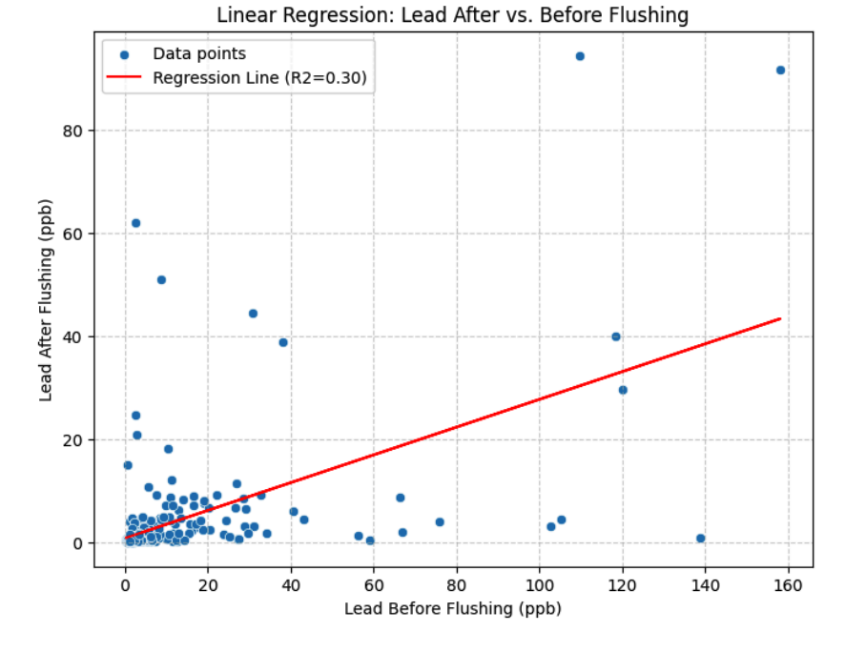

5. Recommendations
Based solely on this analysis of the provided data:
- Continue Flushing: Given the statistically significant average reduction in lead levels shown by the t-test and visualizations, flushing taps before using water for consumption should continue to be recommended as a general practice to reduce potential lead exposure from stagnant water in plumbing.
- Investigate High-Risk Locations: The analysis identified numerous samples with very high lead levels (outliers), even after flushing. These specific locations warrant further investigation (e.g., checking pipe materials, service line status) as standard flushing may not be sufficiently protective.
- Acknowledge Predictive Limitations: While pre-flush levels have a statistically significant relationship with post-flush levels, the low R-squared (≈30%) indicates that using the first-draw level alone is not a reliable method for predicting the lead level after flushing. Public health guidance should reflect that other factors are major contributors.
- Consider Advanced Analytical Approaches (Optional): For future or more in-depth research on this dataset, exploring data transformations (like logarithmic) to handle skewness or employing non-parametric statistical methods might provide additional insights, especially given the potential violation of assumptions in standard linear regression due to outliers.

6. Conclusion
This analysis successfully utilized Python tools to explore the Flint water sampling data. The findings clearly demonstrate that flushing taps leads to a statistically significant reduction in lead concentrations on average. However, the analysis also revealed substantial variability in lead levels and the presence of concerningly high outliers both before and, crucially, sometimes even after flushing. While a moderate positive relationship exists between pre- and post-flush levels, the former is a relatively weak predictor of the latter (explaining only ~30% of the variance). This underscores that factors beyond the immediate plumbing likely contribute significantly to post-flush lead levels. Overall, the analysis supports flushing as a beneficial practice but highlights the complex nature of lead contamination and the need for attention to high-risk locations where flushing alone may be insufficient.

